1. *A link to your GitHub repository for a NEW project* 
   1. [*https://github.com/jv265/IndividualProjectFinal*](https://github.com/jv265/IndividualProjectFinal)
2. *a.* ***YOUR*** *project showing postman listing all records*

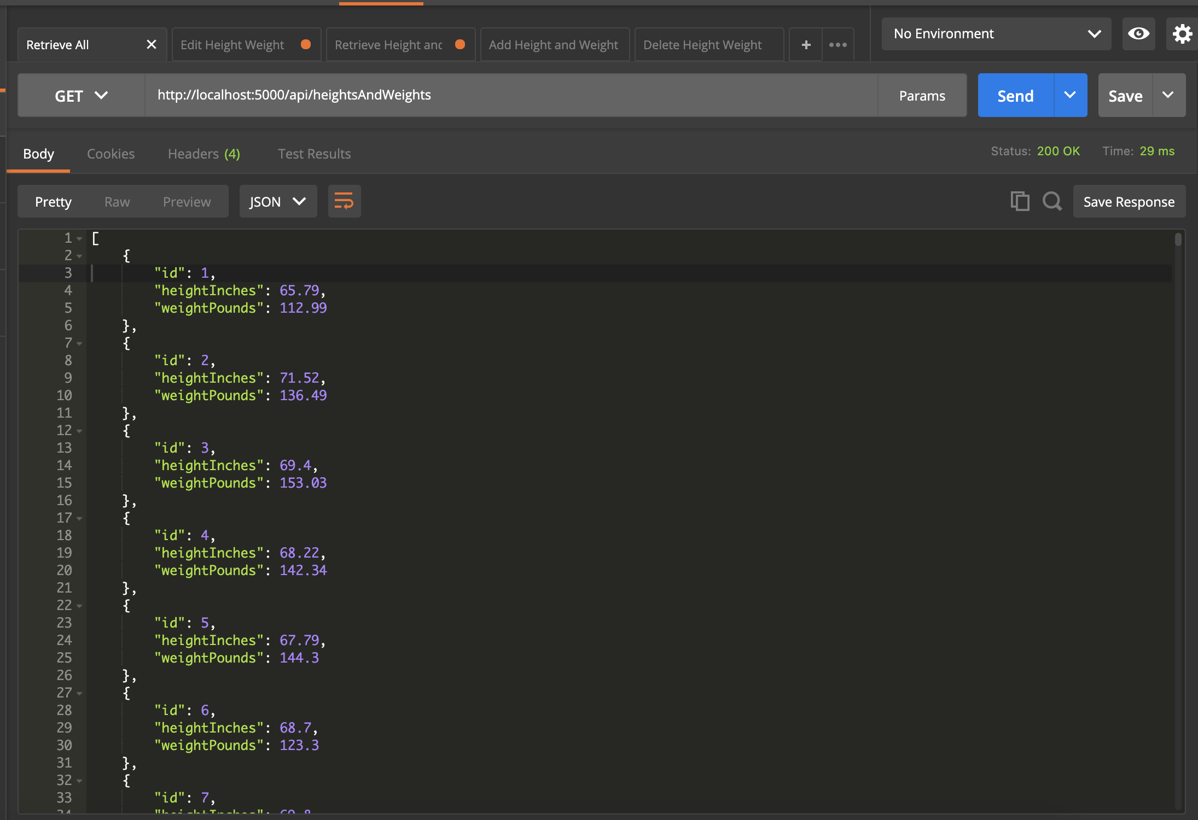

*b.* ***YOUR*** *project showing postman showing one record with a get request*

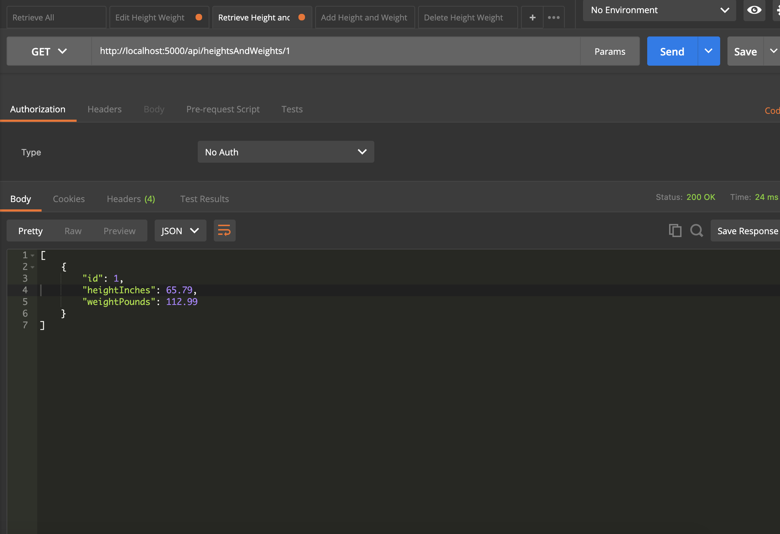

*c.* ***YOUR*** *project showing postman creating a record by showing the post request and the results in the record listing*

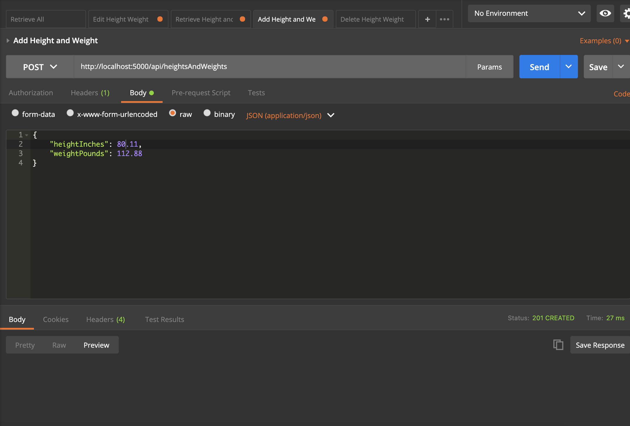

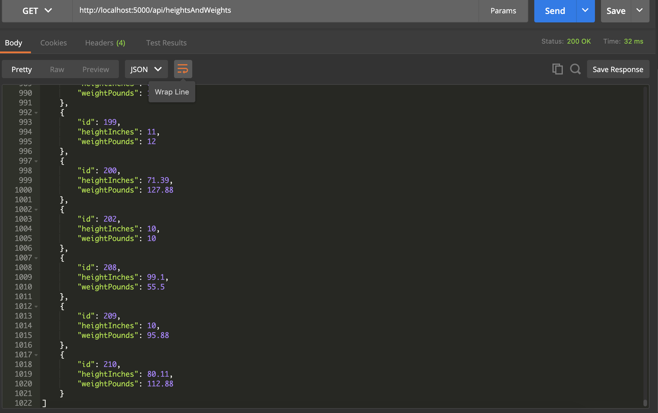

*d.* ***YOUR*** *project showing postman edit a record by showing the put request and the results in the record listing*

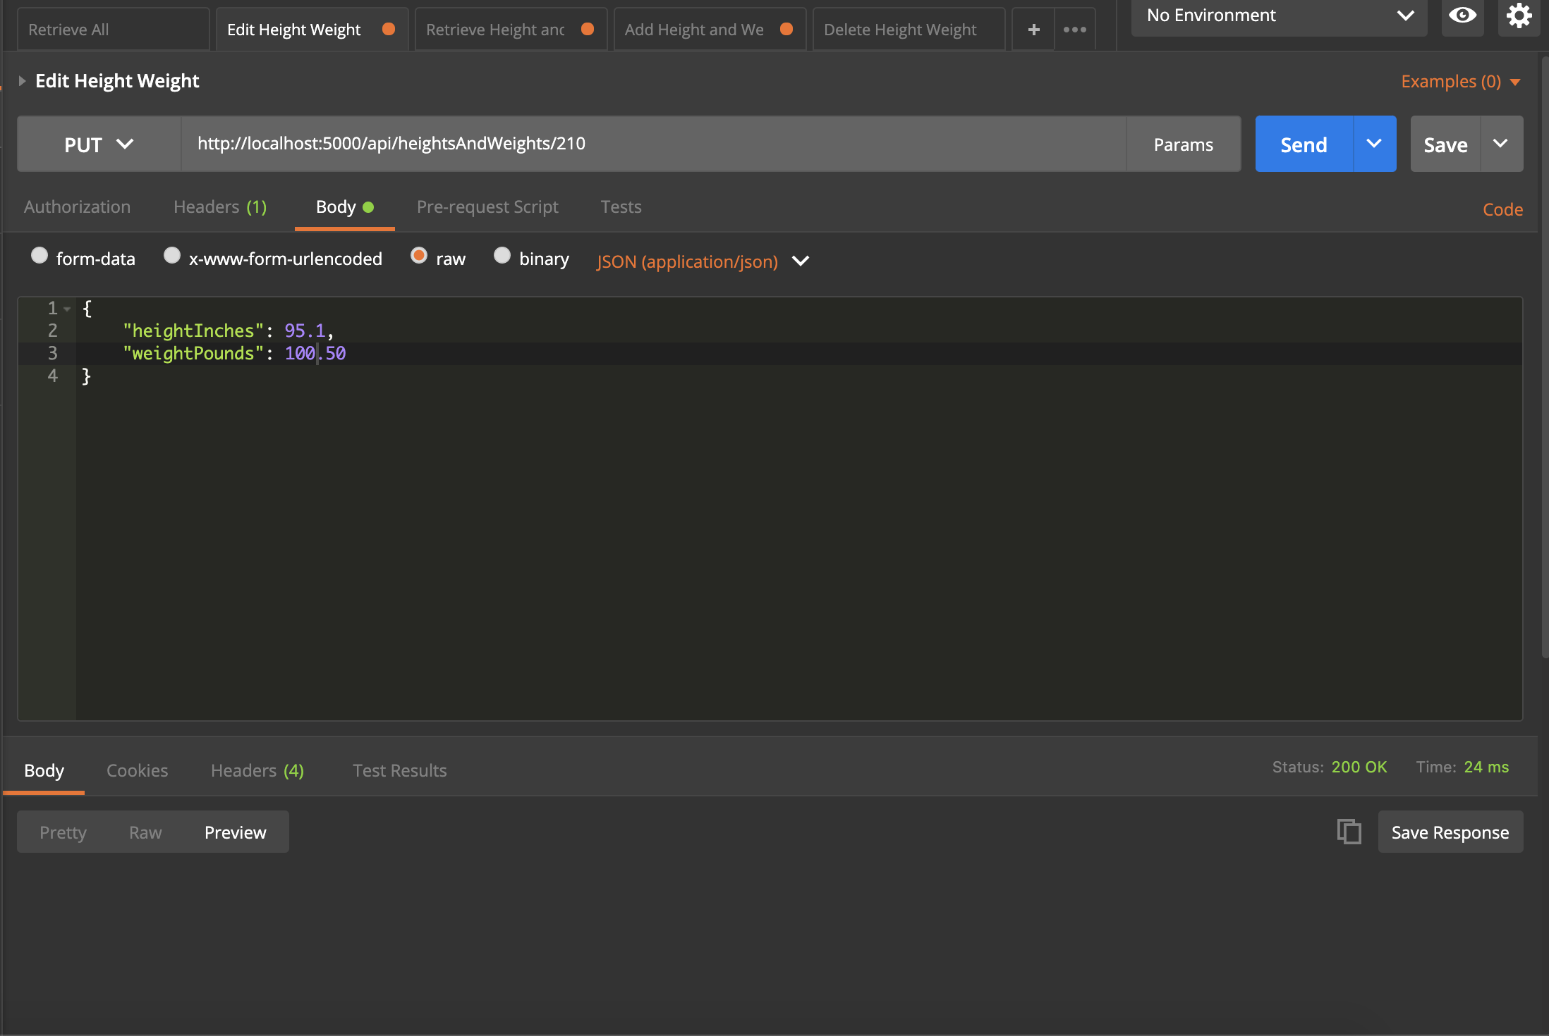

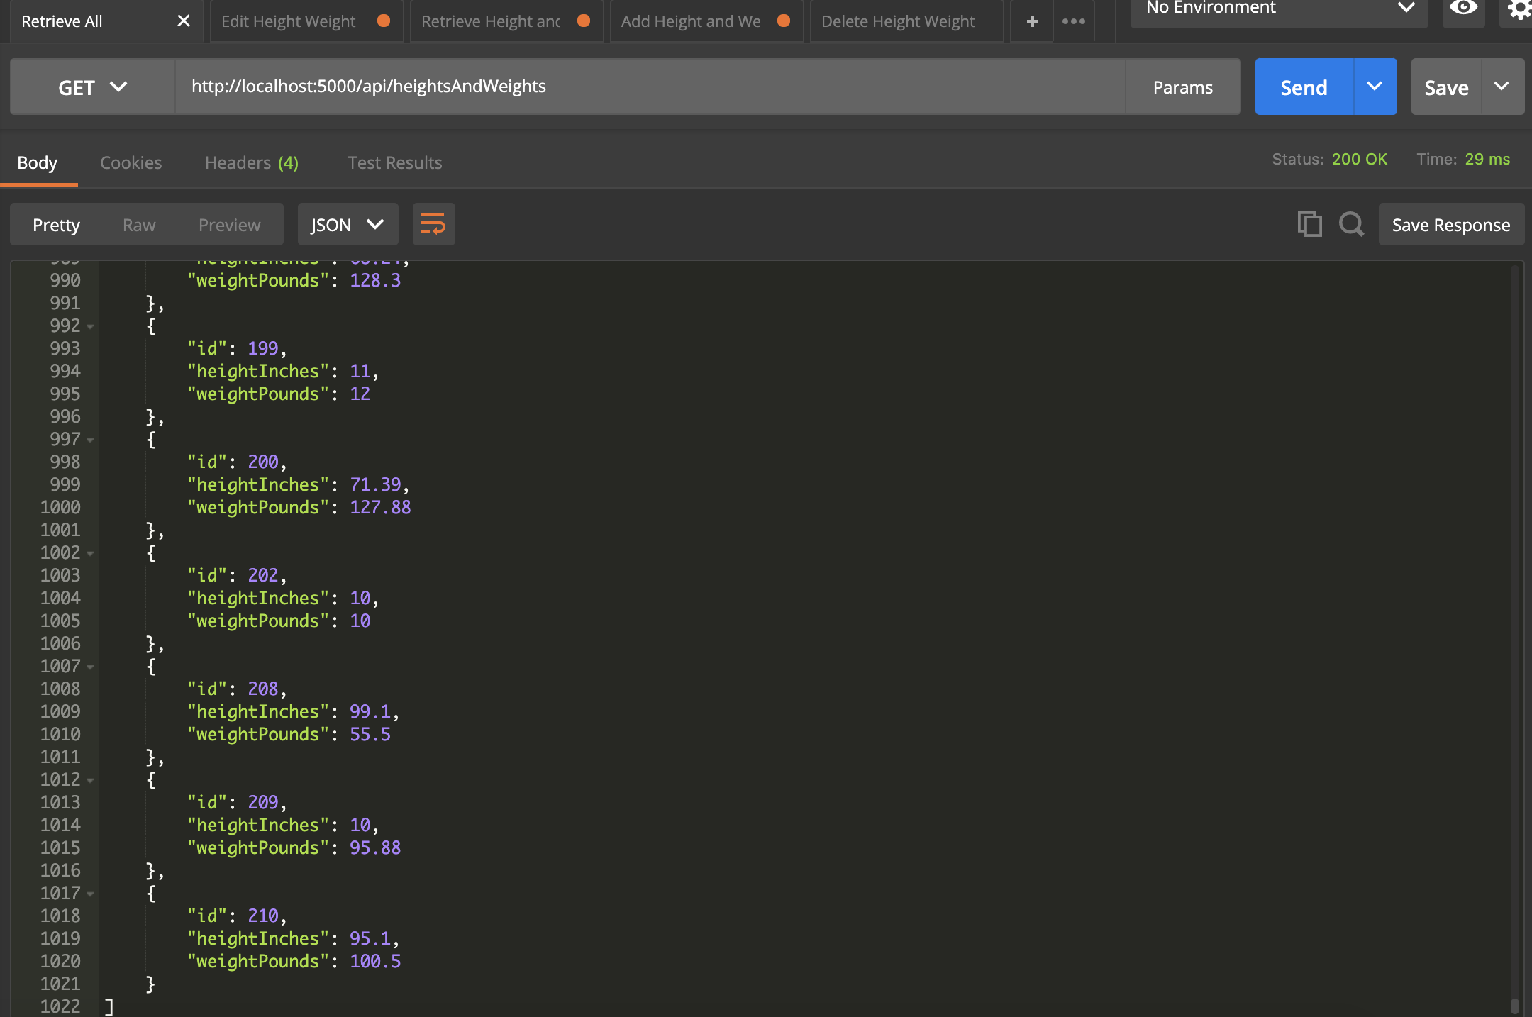

*e.* ***YOUR*** *project showing postman delete a record by showing the delete request and the results in the record listing*

